Jenkins integrate with Bit bucket:

Step 1: we need to create remote repository on bit bucket and push the updates from local to bit bucket repository.

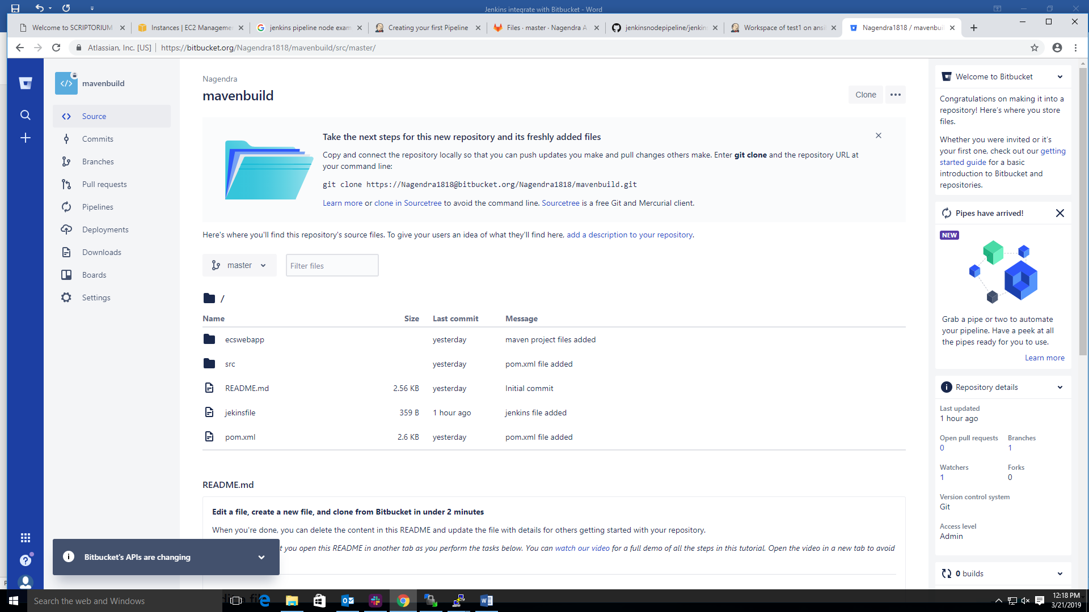

Step 2: now we enable the web-hooks on bit bucket follow the below process

Click on settings 🡪 click on webhooks

Title: enable

url: enable

status: enable

request history: enable

trigger: enable

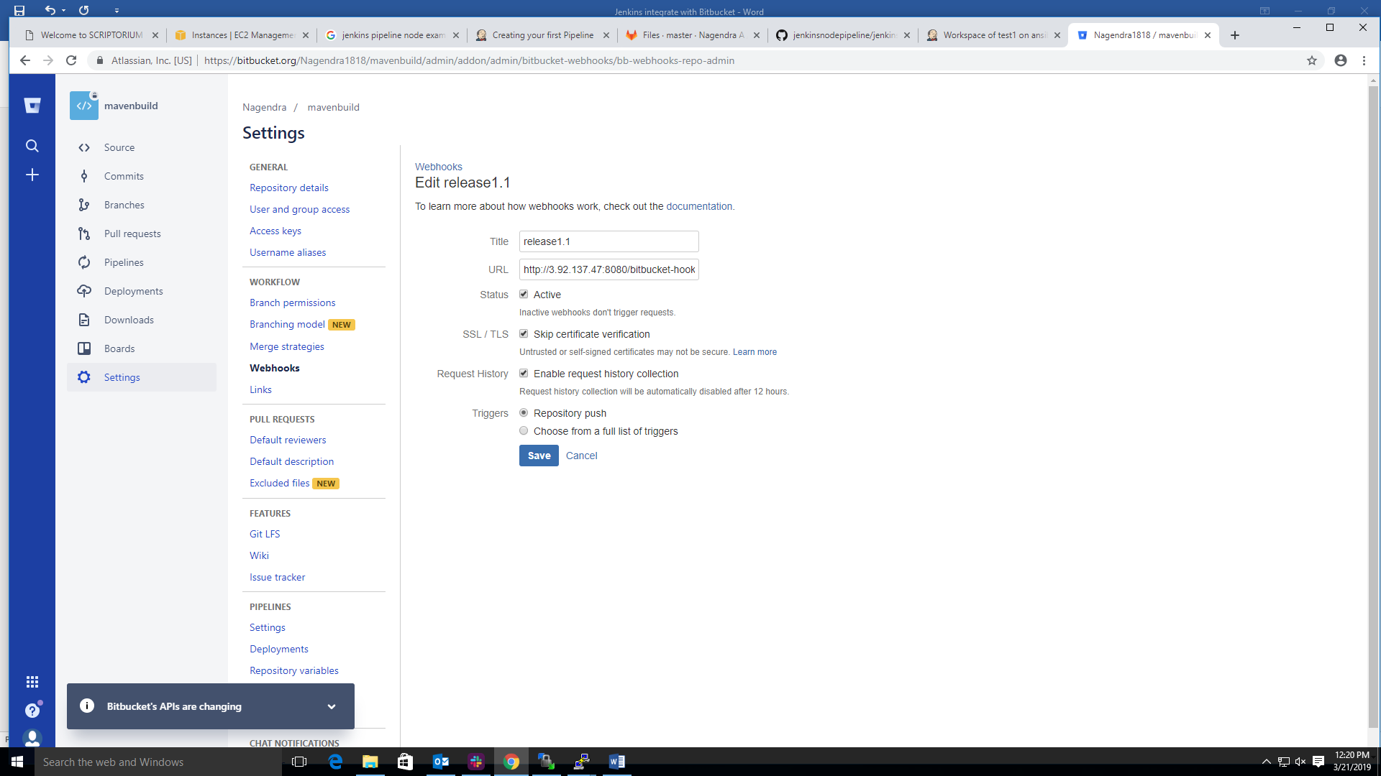

Step 3: we need to install the bitbucket plugin on Jenkins as shown below screen shot.

Click on manage_jenkins 🡪 double click on manage plugins 🡪 choose and double click on available 🡪 search plugin with the help search box 🡪 select Bitbucket 🡪 choose and double click on install without restart option.

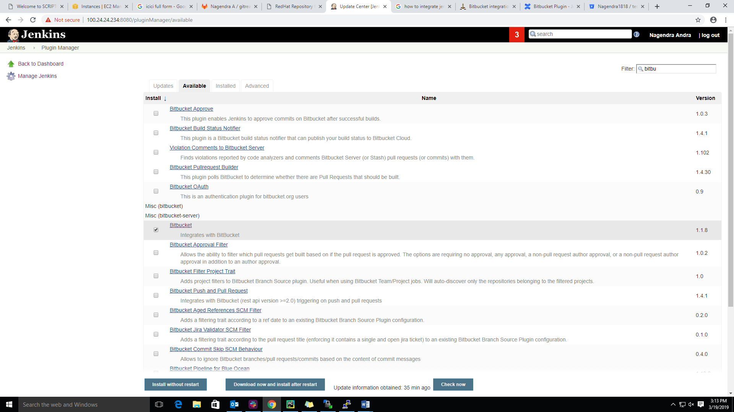

Step 3: we need to create the job on Jenkins as shown in below screen shot.

In this screen shot we need to add the repository-url and credentials

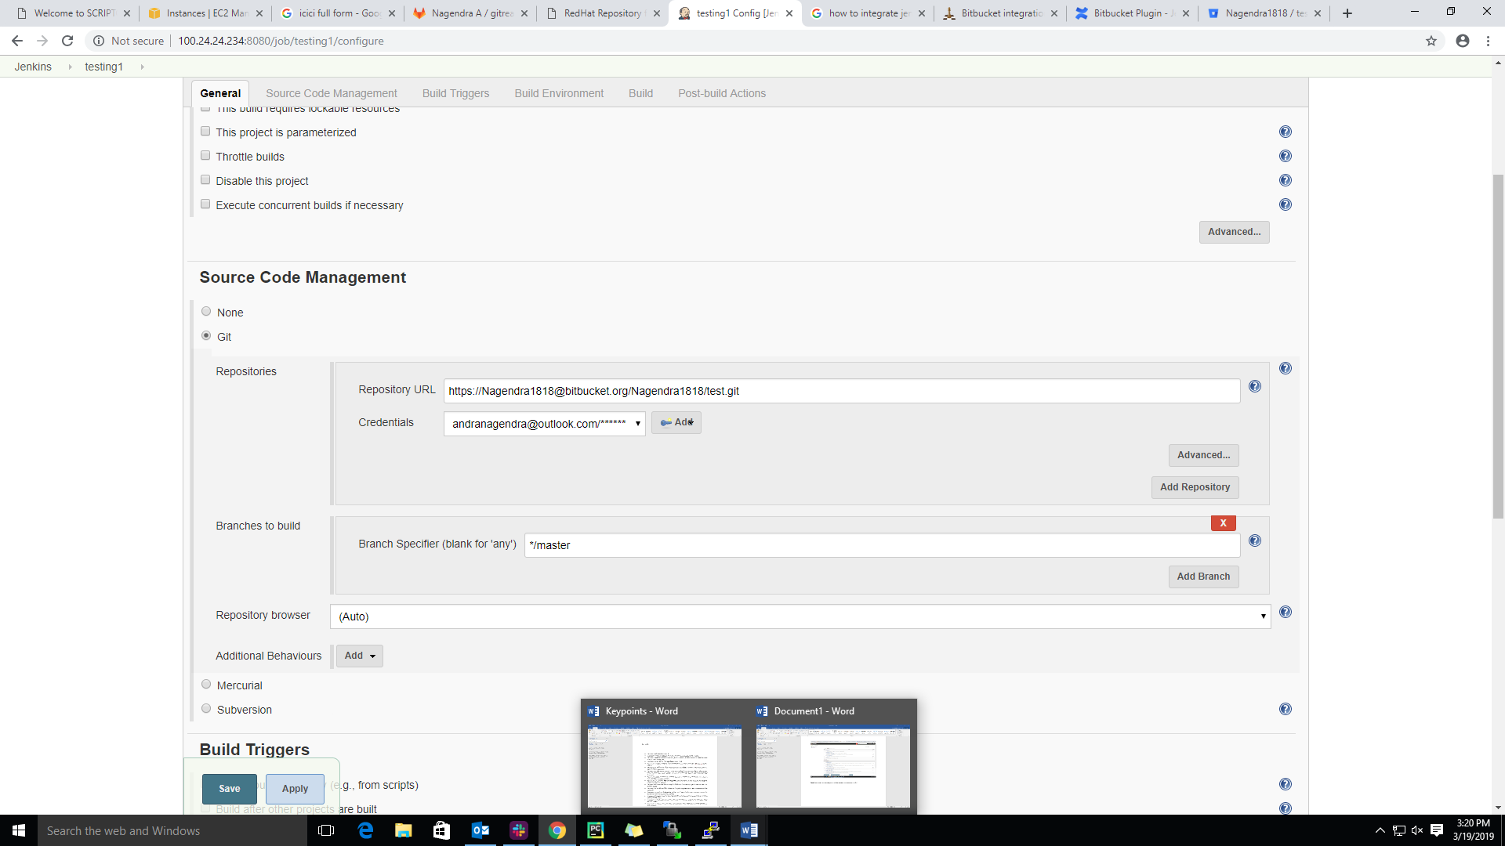

Step 3: we need to **go Build trigger** section choose Build **when a change is pushed to Bit Bucket** as shown in below screen shot. Click on the apply and save.

